**Concept**

Once a player has reached a certain milestone (perhaps if the total wealth and population of the planet exceeds a certain number) with their original planet they can begin starting new planets.

To do so a new button will appear on screen that allows players to zoom out into a larger solar system view. From this view players can see a larger area and if they have multiple planets they will be able to see them all from this view with their stats around them. From this view if the player selects a planet the view will return to displaying just that planet (The main game screen) but by returning to the solar system the player can view and select different planets from their solar system to interact with.

From the solar system view players have the option to generate a new base rock in the solar system in order to start a new planet alongside their original planet, this could potentially cost in game currency, perhaps players can earn a new base rock through reaching greater amounts of wealth on their other planets but could also pay to get one immediately.

Once a player receives a new base rock they may tap within the solar system to place it and it begins life in the same way as the player’s original planet and can be built up in the same way. In order to switch between planets players can zoom out to solar system view and select the planet they wish to switch to in order to interact with it in the main game screen.

**Example**

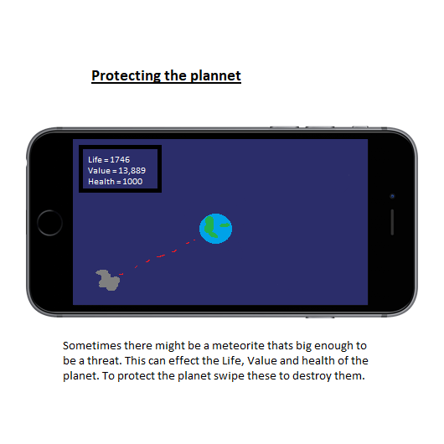

Upon reaching a high enough level of life and wealth on a player’s first planet to ensure that they understand the game the solar system button appears here.

A button on the solar system panel becomes available if the player can establish a new planet. Clicking it allows the player to place a new base rock on the solar system screen. This can be interacted with as any other planet at that point

In solar system view all planets are visible with their stats. Clicking on a planet brings the player to the main game screen for that planet

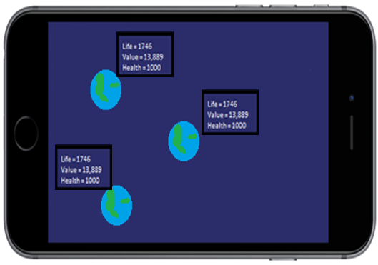

**What can we do from Solar System View?**

Select different planets

See all of your planets with their individual statistics

Begin new planets

Potentially (See asteroid travel paths from a greater distance)

**Interplanetary interaction**

What interactions can occur between planets?  
Send wealth and lifeforms from one planet to another

If this is implemented an additional button on the solar system screen could allow players to select a planet to give and a planet to receive wealth and lifeforms, a ship will begin to launch from one planet and over the course of time will arrive at the destination.  
5% of a planets total wealth and lifeforms will be sent (value subject to balance)